OOP Lab: Experiment 8

Submitted By: Aryan Saxena

Batch: B1

SAP Id: 500082431

Roll No.: R214220274

**Exercise 1:** Write a program for searching strings for the first occurrence of a character or substring and for the last occurrence of a character or substring.

Code:

import java.util.*;

public class Occurance

{

    int nonRepeat(String s)

    {

        int index = -1;

        char arr[] = new char[256];

        for(int i = 0; i < s.length(); i++)

        {

            arr[s.charAt(i)]++;

        }

        for(int i = 0; i < s.length(); i++)

        {

            if(arr[s.charAt(i)] == 1)

            {

                index = i;

                break;

            }

        }

        return index;

    }

    public static void main(String args[]) {

        Scanner sc = new Scanner(System.in);

        Occurance obj = new Occurance();

        String s;

        System.out.print("Enter String: ");

        s = sc.nextLine();

        int index = obj.nonRepeat(s);

        if(index == -1)

            System.out.println("No Repeating Character!");

        else

        {

            System.out.println("1st Repeated Character is: " + s.charAt(index));

        }

    }

}

## Output:

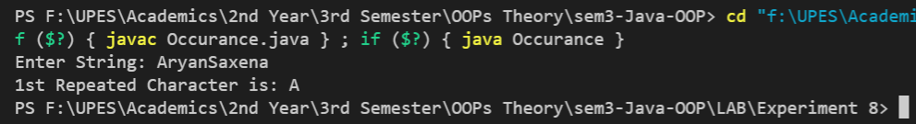

**Exercise 2:** Write a program that converts all characters of a string in capital letters. (Use StringBuffer to store a string). Don’t use inbuilt function.

## Code:

import java.util.*;

public class CapitalBuffer

{

    public static void main(String[] args)

    {

        Scanner sc = new Scanner(System.in);

        StringBuffer str = new StringBuffer();

        System.out.println("Enter a String: ");

        String s = sc.nextLine();

        str.append(s);

        for(int i = 0; i < str.length(); i++) {

            if(str.charAt(i) >= 'a' && str.charAt(i) <= 'z') {

                char c = str.charAt(i);

                c = (char)((int)c - 32);

                str.setCharAt(i, c);

            }

        }

        System.out.println("Capital Converted: " + str);

        sc.close();

    }

}

## Output:

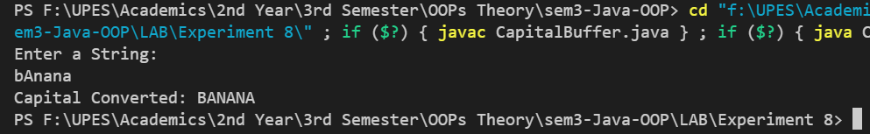

**Exercise 3:** Write a program in Java to read a statement from console, convert it into upper case and again print on console. (Don’t use inbuilt function)

## Code:

public class ConsoleCase

{

    public static void main(String[] args) {

        StringBuffer str = new StringBuffer();

        str.append(args[0]);

        for(int i = 0; i < str.length(); i++) {

            if(str.charAt(i) >= 'a' && str.charAt(i) <= 'z') {

                char c = str.charAt(i);

                c = (char)((int)c - 32);

                str.setCharAt(i, c);

            }

        }

        System.out.println("Capital Converted: " + str);

    }

}

## Output:



**Exercise 4:** Write a program in Java to create a String object. Initialize this object with your name. Find the length of your name using the appropriate String method. Find whether the character ‘a’ is in your name or not; if yes find the number of times ‘a’ appears in your name. Print locations of occurrences of ‘a’ .Try the same for different String objects.

## Code:

import java.util.*;

public class Atimes

{

    public static void main(String[] args)

    {

        int Ticker = 0;

        Scanner sc = new Scanner(System.in);

        System.out.println("Enter String: ");

        String s = sc.nextLine();

        String str = new String(s);

        StringBuilder result = new StringBuilder();

        for(int i = 0; i < str.length(); i++) {

            if(str.charAt(i) == 'a') {

                Ticker++;

                result.append(i + " ");

            }

        }

        if(Ticker != 0) {

            System.out.println("Number of occurences: " + Ticker);

            System.out.println("The index of occurences: " + result);

        }

        else {

            System.out.println("Character not present");

        }

    }

}

## Output:

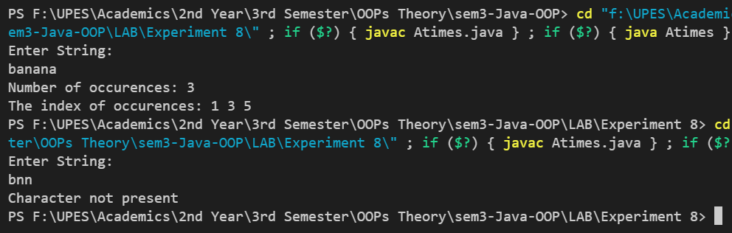

**Exercise 5:** Write a Java code that converts int to Integer, converts Integer to String, converts String to int, converts int to String, converts String to Integer converts Integer to int.

## Code:

public class ConversionGames

{

    public static void main(String[] args)

{

        int a = 99;

        System.out.println("The int value is: " + a);

        Integer inta = Integer.valueOf(a);

        System.out.println("int to Integer: " + inta);

        String s = Integer.toString(inta);

        System.out.println("Integer to String: " + s);

        int Int2Str = Integer.parseInt(s);

        System.out.println("String to int: " + Int2Str);

        String Str2Int = String.valueOf(Int2Str);

        System.out.println("int to String: " + Str2Int);

        Integer Str22Int = Integer.valueOf(Str2Int);

        System.out.println("String to Integer: " + Str22Int);

        int IntFinal = Str22Int.intValue();

        System.out.println("Integer to int: " + IntFinal);

    }

}

## Output:

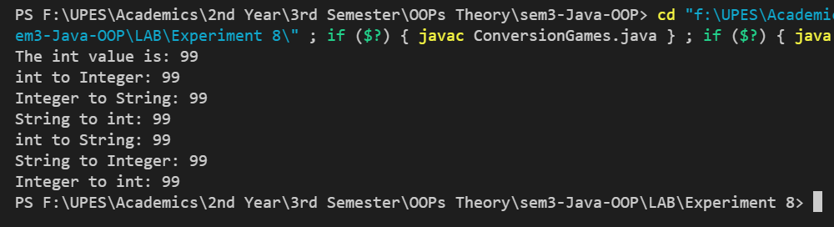

**Exercise 6:** Write a Java code that converts float to Float converts Float to String converts String to float converts float to String converts String to Float converts Float to float.

## Code:

public class ConverstionGamesFloat

{

    public static void main(String[] args) {

        float f = 99f;

        Float V1 = Float.valueOf(f);

        System.out.println("float to Float: " + V1);

        String Str = String.valueOf(V1);

        System.out.println("Float to String: " + Str);

        float V2 = Float.parseFloat(Str);

        System.out.println("String to float: " + V2);

        String Str2 = String.valueOf(V2);

        System.out.println("float to String: " + Str2);

        Float V3 = Float.valueOf(Str2);

        System.out.println("String to Float: " + V3);

        float V4 = V3.floatValue();

        System.out.println("Float to float: " + V4);

    }

}

## Output:

